Tamkang Times No.972
TKU Triumphs in Robotics Competition

From July 16th to the 18th there was a three-day contest titled the “National Robotics Competition” at the Nangang Exhibition Hall featuring three events: the 2015 Robotics Innovation Competition, the 8th Annual HIWIN Intelligent Robotics Implementation Competition and the 2015 SKS Intelligent Robotics Competition. On July 19th the Department of Electrical and Computer Engineering’s robotic smart arms, “Bumble Bee MIT” and Bumble Bee Evo” won the 8th Annual HIWIN Intelligent Robotics Implementation Competition and took second place in the 2015 Robotics Innovation Competition in categories of TKU-DELTA Robotic Sensor Applications and the Tamkang Arm.

The robotics team, “Robot Research Team”, was lead by Professors of the Department of Electrical and Computer Engineering, Ching-chang Wang and Chi-yi Tsai. Professor Wang expressed, “The competition this year increased in difficulty. The final match included categories of the Domino Effect, Mechanical Writing, Hand and Eye Coordination and Stacking. Not only did the robotic arm have to move quickly, it also had to be very precise and stable. For the Domino Effect the robot had to set up a minimum of 25 dominos in only 5 minutes. The Bumble Bee MIT not only quickly set up 34 dominos, it was one of the only teams that all of the pieces were close enough to fall correctly.”

For the Mechanical Writing event the robotic arm had to be able to write the Chinese characters “上銀“ (HIWIN), which the Bumble Bee MIT performed quite gracefully, winning first place. For the Hand and Eye Coordination event, the robots had to use sensors to detect holes in the surface, colors and shapes in order to put together a puzzle. For the Stacking event, the robot had to stack a pile of 20 wooden pieces to a height of 25 centimeters. Professor Yin-tien Wang of the Department of Electrical Engineering, expressed, “This competition really helps guide the students learning by giving them a chance to realize their ideas.”
2015/08/25

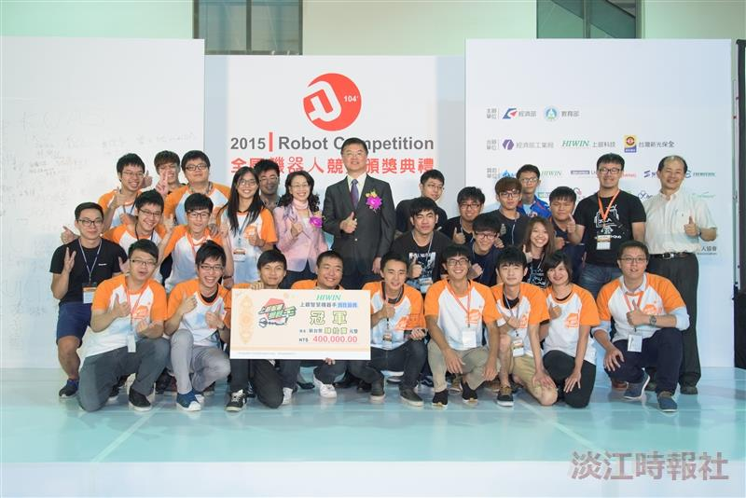
The Department of Electrical and Computer Engineering and the Department of Mechanical and Electro-Mechanical Engineering performed beautifully in the 2015 Robot Competition. (Photo provided by Department of Electrical and Computer Engineering.)

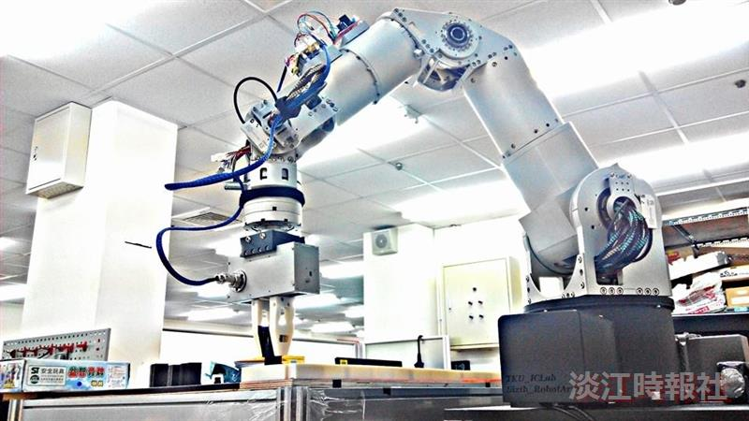
Picture of Bumble Bee Evo (Photo provided by Department of Electrical Engineering)

